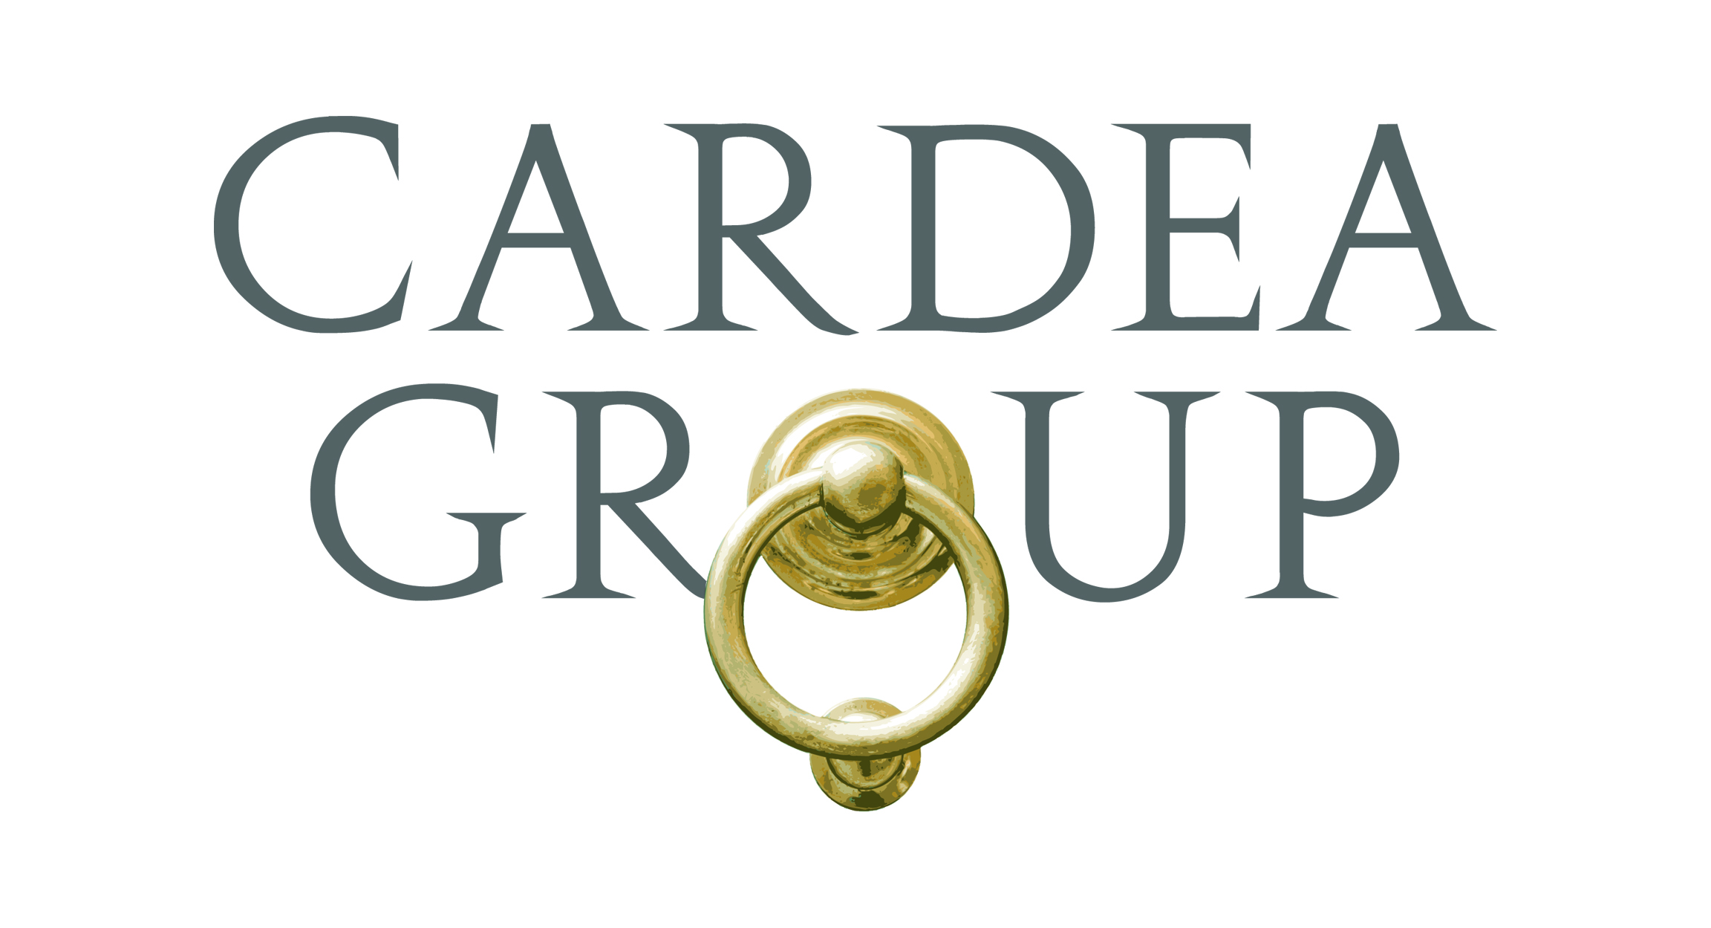
Candidate Name

EXPERIENCE
Top Tier Law Firm, New York, NY April xxxx – Present
Associate, Mergers & Acquisitions Group
- Represent clients in a variety of both public and private mergers and acquisitions transactions
- Negotiate and draft transaction documents, including stock purchase agreements, asset purchase agreements, merger agreements, and other general transactional and governance documents
- Conduct due diligence review and draft diligence reports
- Draft and review disclosure schedules; draft and file various disclosure documents for SEC reporting companies, including Forms 13D, 13G, 8-K and Schedule 14D-9
- Manage the closing of transactions, including overseeing specialists attorneys and coordinating the closing with various internal departments at the client
- Assist clients with ongoing corporate governance matters, including drafting organizational documents, consents, closing certificates and board resolutions
- Provide continued advice and support to clients on post-closing and general corporate matters

International Law Firm, New York, NY October xxxx – March xxxx
Associate, Mergers & Acquisitions Group
Summer Associate (Summer xxxx)
- Represented clients in a variety of both public and private mergers and acquisitions transactions
- Negotiated and drafted transaction documents, including stock purchase agreements, asset purchase agreements, merger agreements, limited liability company agreements and other general transactional and governance documents
- Conducted due diligence review and drafted diligence reports
- Drafted and reviewed disclosure schedules
- Drafted and filed various disclosure documents for SEC reporting companies, including Forms 13D, 13G and 8-K
- Managed the closing of transactions, including overseeing specialists attorneys and coordinating the closing with various internal departments at the client
- Assisted clients with ongoing corporate governance matters, including drafting organizational documents, consents, closing certificates and board resolutions
- Provided continued advice and support to clients on post-closing and general corporate matters
- Completed rotations in the Capital Markets and Executive Compensation Groups

Investment Bank, New York, NY May xxxx – December xxxx
Secondment to Mergers & Acquisitions Legal Department
- Represented the firm in a variety of merger and acquisitions transactions
- Reviewed transaction documents, presented issues to the business team and provided comments to outside counsel
- Participated in various meetings with business teams, including transaction negotiations and prospectus drafting sessions
- Drafted transaction summaries for business and legal committee approval
- Coordinate pro bono activities with an inner-city middle school

EDUCATION
ABC University School of Law, New York, NY May xxxx
J.D.
- magna cum laude; GPA: 3.64

XYZ University, New York, NY Fall xxxx
M.A. International Political and Economic Development
- Specialization: Finance and Banking
- GPA: 3.56/4.0

123 University, New York, NY May xxxx
Bachelor of Science, Accounting; Minor, Economics
- summa cum laude; GPA: 3.83/4.0
- Honor society; Dean’s List

BAR ADMISSIONS
New York

