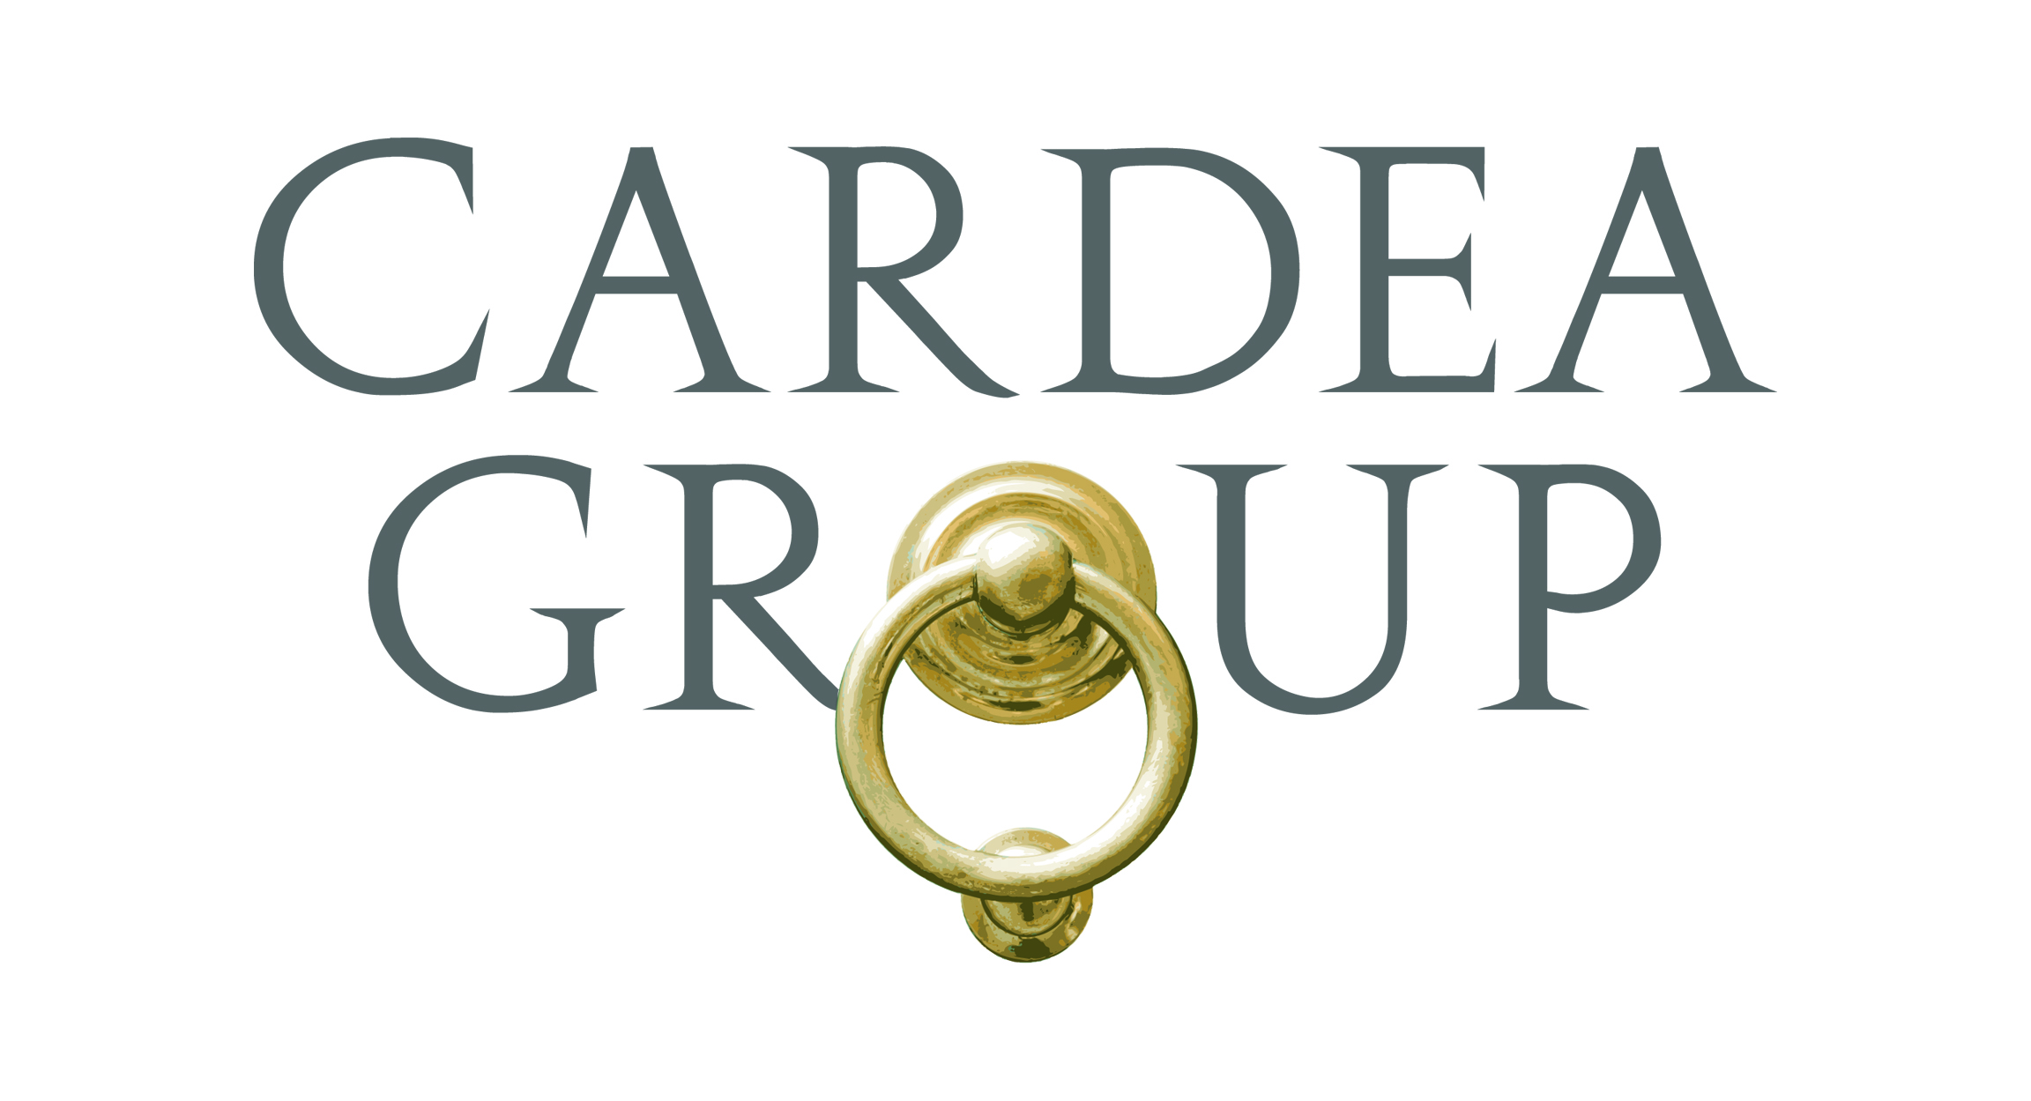
Candidate Name

EXPERIENCE
Leading Hedge Fund, New York, NY August xxxx – October xxxx
Compliance Associate
- Maintain a robust compliance program by frequent testing and monitoring rules, policies, and procedures, providing firm-wide and topic-specific trainings, working closely with operations, senior management and external consultants
- Partner with portfolio managers and traders to monitor international and U.S. positions filing; manage daily portfolio pre-trade and post-trade alerts and warnings
- Research regulatory developments and trends to provide advice and guidance on company initiatives
- Assist the CCO in responding SEC exam requests and facilitating employee interviews
- Advise the firm on alternative data and vendor management, including risk assessment, due diligence and ongoing monitoring
- Participate in Valuation Committee and Trading Committee and provide enhancements to portfolio surveillance
- Provide assistance to investment initiatives by conducting research on legal cases, proxy votes and corporate documents
- Manage day-to-day responsibilities and implementation of compliance program, including chaperoning expert network calls, maintaining the Restricted List, assisting with ad-hoc trainings, and educating investment and non-investment staff on the firm’s policies
- Assist with forensic testing and various regulatory filings, while continuously monitoring internal events to identify potential areas of improvement to strengthen compliance program
- Perform due diligence reviews on executing brokers, research, and alternative data vendors, in addition to third-party managers
- Work internally with senior members of the firm across different business lines and locations to collaborate on efforts to develop and build out new internal infrastructure to adapt to global environment

Global Asset Manager, New York, NY May xxxx – July xxxx
Legal, Compliance & Risk Analyst
- Assisted with the development and implementation of the firm’s advisory compliance program and administered the Code of Ethics system
- Performed daily surveillance of portfolio trading compliance reports for sub advised accounts, separately managed accounts, mutual funds, passive investing products, ERISA accounts and UCITS; monitored and reviewed investment guidelines and restrictions; and worked with Portfolio Management and Operations to resolve trading issues, i.e., alerts and warnings
- Prepared domestic and international regulatory filings (including Form ADV; Form 13F and 13H, FINRA, and Ukrainian regulators)
- Contributed to the firm’s policy development in connection with trade error, new business/product, third party vendor management, and cybersecurity
- Conducted risk-based assessments, identified potential operational risks and provided recommendations to lines of business
- Maintained and monitored Value Added Investors List and Sensitive List to ensure compliance with Information Barriers Policies and Procedures
- Participated in review and approval of new business/product and provided responses to periodic RFPs
- Conducted research on regulatory advisor matters under the Investment Advisers Act of 1940 and other laws, rules and regulations and reviewed IMAs and client contracts

EDUCATION
ABC University, New York, NY May xxxx
Bachelor of Science in Accounting, Minor in Finance

SKILLS
Computer: MS Excel, Word, PowerPoint, Outlook, Project, SharePoint, Visual Basic, Java

INTERESTS
Reading, Cooking, Tennis, International Travel, Steeley Dan, Rock Climbing, Yoga

