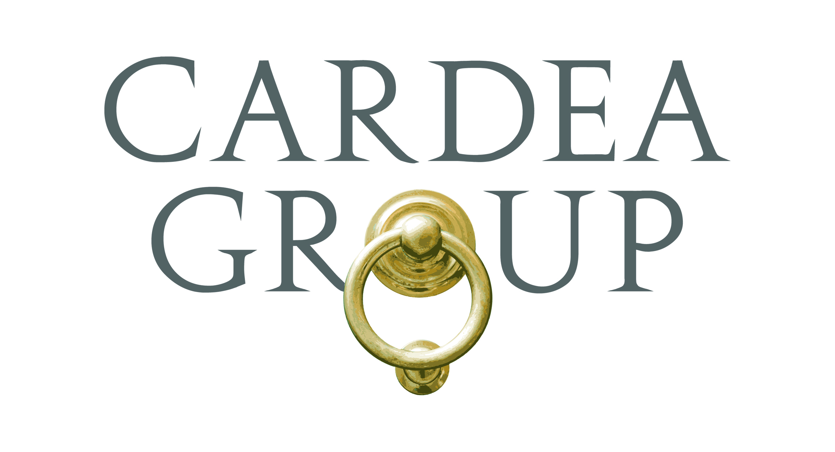
Candidate Name

EXPERIENCE
$4B Fund of Hedge Funds, New York, NY June XXXX – Present
Chief Compliance Officer
- Responsible for the firm’s compliance with its various regulatory responsibilities as a registrant with the U.S. Securities and Exchange Commission (SEC), the Commodity Futures Trading Commission (CFTC), and a member of the National Futures Association (NFA); which includes overseeing the submission of periodic filings/disclosures, administering various regulatory-related internal policies and protocols, and addressing and executing numerous one-off tasks and exercises with respect to such regulatory bodies.
- Responsible for the Funds’ compliance with their respective regulatory responsibilities in connection with the SEC, the CFTC, SEBI, the Cayman Islands Monetary Authority (CIMA), and any foreign filing or disclosure requirement, as and where applicable, relating to any of the Fund’s international ownership interests, trading, or short-selling.
- Integrally involved in any examination conducted by any regulatory body as well as responsible for overseeing periodic filings for the Federal Reserve and the U.S. Bureau of Economic Analysis (BEA), as applicable or requested.
- Monitor and, if necessary, implement measures for the Firm’s and the Funds to comply with the wide variety of developments in regulatory compliance pursuant to Dodd Frank and other such recently promulgated domestic and international regulatory regimes that have directly or indirectly impacted numerous areas of the Firm’s business such as accounting (i.e. Form PF), investment manager/fund administration (i.e. JOBS Act Bad Actor Provisions, Regulation S-ID, Cayman Offshore Director Registration), information technology (i.e. OCIE Cybersecurity Initiative), investor relations (i.e. AIFMD, CISA, JOBS Act – Rule 506(c)), taxation (i.e. FATCA, UK FATCA), and trading/operations (i.e. Dodd Frank Protocols, Cross Borders, Swap Reporting, OTC Clearing, SEFs, Initial Margin Segregation, EMIR, Canadian Regulatory Reporting Requirements for OTC Derivatives).
- Preside over the day-to-day administration and enforcement of the Firm’s internal compliance program such as overseeing the Firm’s Anti-Money Laundering and Foreign Corrupt Practices Act programs (including conducting their respective annual trainings), vetting and monitoring expert networks, monitoring compliance with the Custody Rule, monitoring the QIB status of the Funds, reviewing trade discrepancies, reviewing any soft dollar arrangements, reviewing any cross trades, addressing questions relating to allocation, screening PIPEs, conducting email surveillance, maintaining restricted securities list, monitoring the personal trading of those individuals covered by the Firm’s Code of Ethics (each, a “Covered Person”), reviewing and approving political contribution requests for all Covered Persons, analyzing and overseeing compliance with various state and municipal lobbying registration requirements, administrating Compliance & Brokerage and Valuation committees, periodically updating/revising the Compliance Manual and Employee Handbook in accordance with any developments in applicable law/regulation and/or best practices, administering periodic office-wide compliance trainings, conducting new-hire compliance training, producing Annual Compliance Report, conceiving of and drafting bi-monthly office-wide compliance memos that address a variety of relevant compliance-related topics, and addressing any other compliance related matters that may arise in the course of ordinary business.
- Work closely with the General Counsel, Chief Operating Officer, Chief Financial Officer, Investment Risk Manager, Investor Relations Department, Information Technology Department, and Tax Department as well as being responsible for retaining, working with, and supervising outside legal counsel with respect to compliance-related matters.

$2B Mutual Fund, New York, NY March XXXX – June XXXX
Associate Corporate Counsel (August XXXX – June XXXX)
Compliance Associate (March XXXX – August XXXX)
- Well-versed in the Investment Advisers Act of 1940 with a working understanding of various SEC regulations and requirements such as Form ADV, Form 13F, Form 13H, and Schedule 13G as well as a working familiarity with the Investment Company Act of 1940.
- Drafted the the Firm’s Social Media Policy and Pay-to-Play Policy and Procedures; updated and improved the Anti-Money Laundering Policy and Procedures; in cooperation with the Department Heads of Trading, Wrap Trading and Technology, developed and implemented a monitoring program for the wrap trading accounts; and generally enforced the Compliance Program.
- Presided over the day-to-day monitoring and enforcement of the Code of Ethics Program, which included monitoring the personal trades of all employees with the assistance of Protegent Personal Trading Assistant (PTA); administered, maintained, and periodically tested the integrity of PTA and its ability to appropriately monitor the personal trades of all employees; drafted the language for the Code of Ethics quarterly and annual employee certifications; and conducted periodic Code of Ethics training.
- Drafted the Firm’s Online Privacy Policy, Website Terms of Use, and Third Party Non-Disclosure Agreement; negotiated and drafted agreements with third-party vendors and clients: reviewed various contracts and Request-for-Proposals; edited quarterly letters to its funds’ shareholders; and represented the Firm in an employment hearing pertaining to disciplinary action taken in response to Code of Ethics violations.
- Provided counsel to the Firm’s Finance, Trading, Portfolio Management, Technology, Operations, and Compliance Departments; addressed legal matters that arose in the ordinary course of business; and worked closely with outside litigation, regulatory, and employment counsel.

EDUCATION
123 University, School of Law, New York, NY May xxxx
Juris Doctor

ABC University, New York, NY May xxxx
Bachelor of Arts – Concentration History

BAR ADMISSION / COMMITTEE MEMBERSHIPS
Admitted to the Bar of the State of New Jersey (June xxxx)
Admitted to the Bar of the State of New York (June xxxx)

OTHER
USA National Women's Lacrosse Team XXXX - XXXX
Represented the U.S. in competition against elite players from Australia, England, Japan, Canada, etc.

